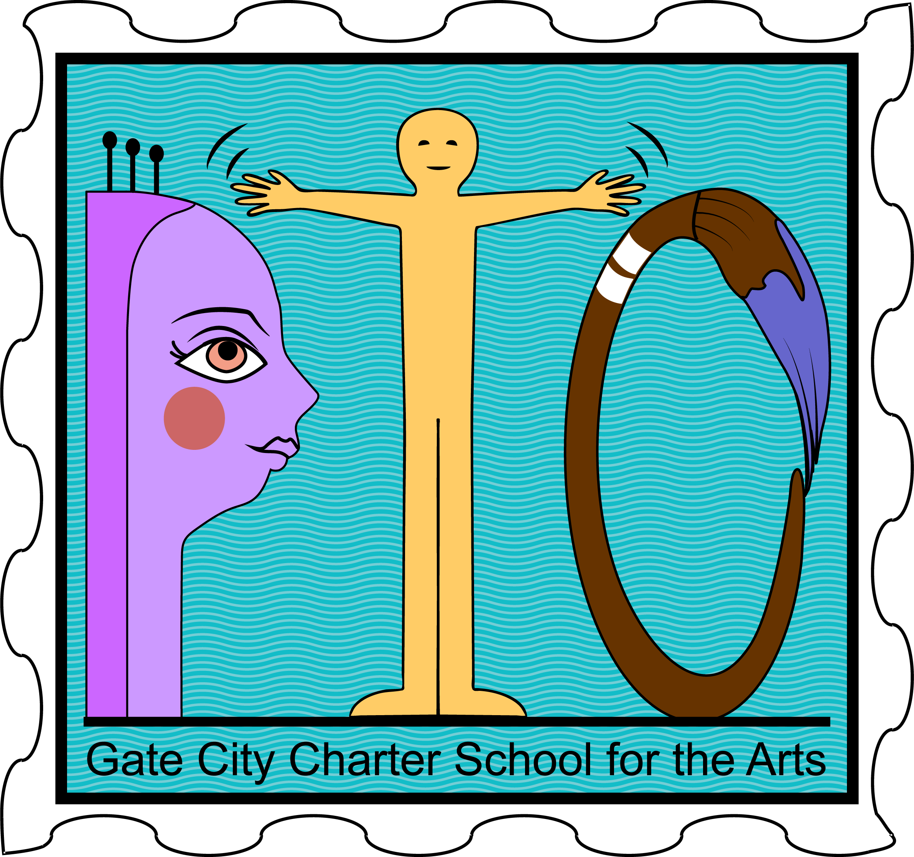

Agenda

GCCSA PTO
Meeting Date: February 11, 2021
Meeting Location: Google virtual meeting at 4:00pm

- Call to Order
- Minutes: review minutes from 1/14/2021
- Officer Reports
  - President: Sarah Thibeault
  - Vice President: Amy Cooper
  - Treasurer: Danielle Charest
  - Administrative Liaison: Astrid Alvarado
  - Elementary Liaison: Nicole Riddell
  - Middle School Liaison: Mary Ellen Wessels
- Committee Reports
  - Virtual Talent Show
  - Yearbook - Julie
- Unfinished Business
  - Mascot
- New Business
  - March Events
  - Ceiling Tiles
- Announcements
- Open Discussion
- Adjournment

